**CSE-6363-Programming Assignment-1**

**Naïve Bayes Algorithm**

Steps to run code:

1. You will find the document to be uploaded in the zip folder.
2. Please enter the filename with the path to the csv or data file with dataset.
3. For the enhancement (Bernoulli, Multinomial) please mention the target attribute.

Note:

1. This document contains only the output of all the code used.
2. The folder contains the python book with all the code.

**Output of the Naïve Bayes Tutorial:**

For data set Hayes-Roth:



For data set Car:

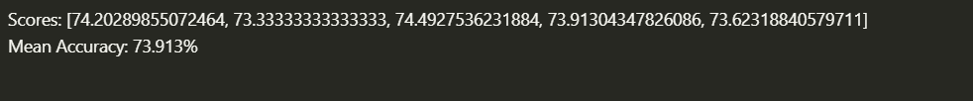

For data set Breast-Cancer:



**For 10 folds:**

This handles the under-float error that is generated with large float values.

Hayes-roth:



Car:



Cancer:

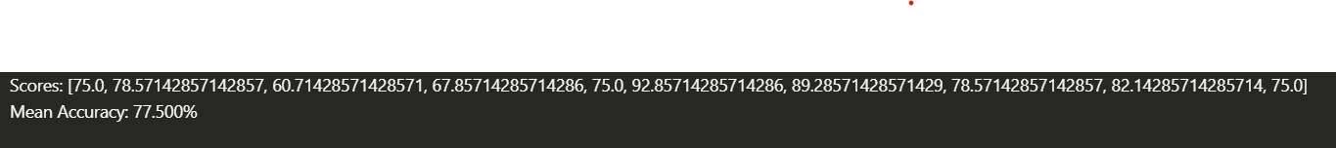

**After Log:**

Roth:



Car:



Cancer:



**Bernoulli:**

Roth:

Car:

Cancer:

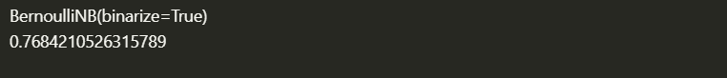

**Multinomial:**

Roth:

Car:

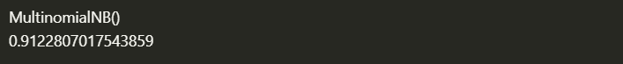

Cancer:

**Hypothesis Testing Output:**

H0= It is considered that the same mean of the weka and python are same.

H1= It is considered that the same mean of the weka and python are not same.

Note: Weka Considering mean of valid dataset and writing it for 10 times to calculate.

Roth:

Car:

Cancer:



**Weka Output:**

**References:**

1. <https://machinelearningmastery.com/naive-bayes-classifier-scratch-python/>
2. <https://machinelearningmastery.com/statistical-hypothesis-tests-in-python-cheat-sheet/>
3. https://www.tutorialspoint.com/machine_learning_with_python/machine_learning_with_python_data_preprocessing_analysis_visualization.htm